# Arduino Unbrick

## Create Arduino Programmer (if not already created)

1. First we connect the working Arduino to our computer and open the Arduino IDE.
2. We go to File -> Examples and click ArduinoISP and upload this to the Arduino.
3. Once uploaded disconnect the Arduino.

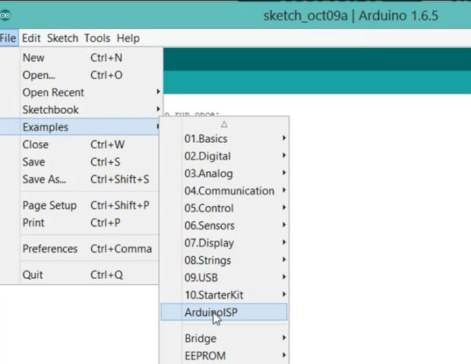

## Chinese Uno R3

1. Next we connect the wires from the working Arduino to the clone as follows.
   1. Pin 10 goes to reset
   2. pin 11 goes to 11,
   3. pin 12 to 12,
   4. pin 13 to pin 13.
   5. 5v to 5v and ground to ground.
   6. Connect a 10 uF capacitor between reset and ground on the working Arduino.

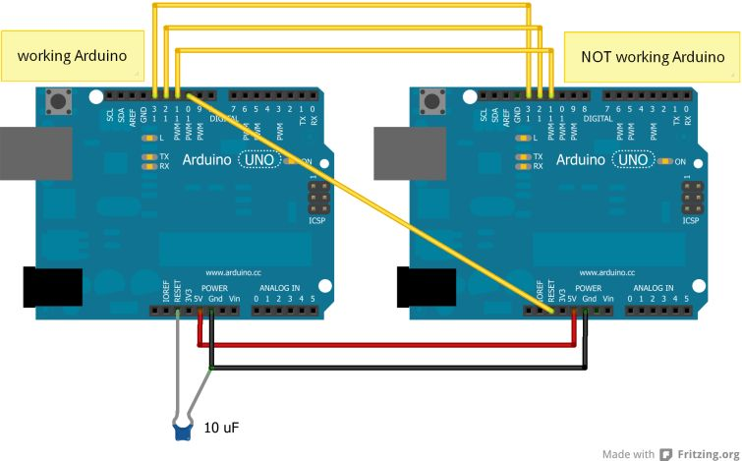

1. Connect the working Arduino with a usb to the computer.
   1. Go to Tools -> Board and select the chinese board that is not working. **Arduino Genuino\Uno**.
   2. Next we go to Tools again -> Programmer and select **Arduino as ISP**.
   3. Go to Tools again and select **Burn Bootloader**.
      1. If it fails run **Burn Bootloader** a couple more times.
   4. Go back to Tools -> Programmer and set back to **ArduinoISP**.

## Leonardo

1. Follow Step 2 under Uno R3

